**Defect Report**

* **Defect Id: 65**
* **Status: Fixed**
* **Reported by: Zeyad**
* **Asserted to: Malek**
* **Date:**  **15/5/2023**
* **Defect Description: After entering the course name = "123", an InvalidCourseNameException must be thrown but nothing was thrown, and the course name was stored normally. The course name must not start with numbers.**
* **Steps:**

1. **Open the application**
2. **Enter course name through Course constructor ="123"**
3. **Run the program**

* **Severity: Low**
* **Priority: High**
* **Date Closed:**
* **Fixed By: Malek**
* 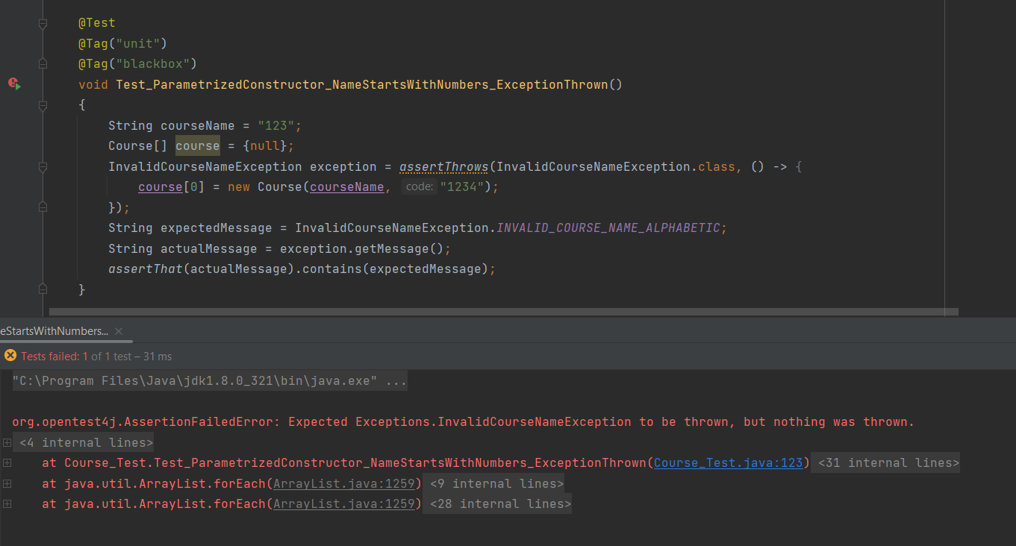**Screenshot for the Defect:**
* **Screenshot after fixing:**

